Computer Networks Test 1 Study Guide

**Module 1**

**For OSI Model:**

**  
**

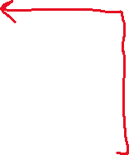



**Module 2**

